This goal of this project was to attain hands-on radio access network (RAN) engineering experience. This report will cover how I used a multi-technology cellular drive-test dataset and RF engineering principles for
- Data characterization
- Measurement validation
- KPI analysis
- Spatial analysis
- Optimization recommendations
Analysis tools include Python utilizing the libraries NumPy, Pandas, Matplotlib, and Seaborn.

Data Characterization
This section provides a dictionary of the measurements in the dataset and their limitations.
Table 1 provides a quick description of the drive-test scenario.
Area | 21 km radius around Patna, Bihar, India
Total # of measurements | 16,829
Network types | 3G, 4G, LTE, 5G¹
Test Density | ~0.8 km/network type
Time period | 36 days at unique times
Table 1: High-level description of scenario
¹LTE was omitted from this analysis
Figure 1 is a sample of the CSV file of the drive-test dataset.
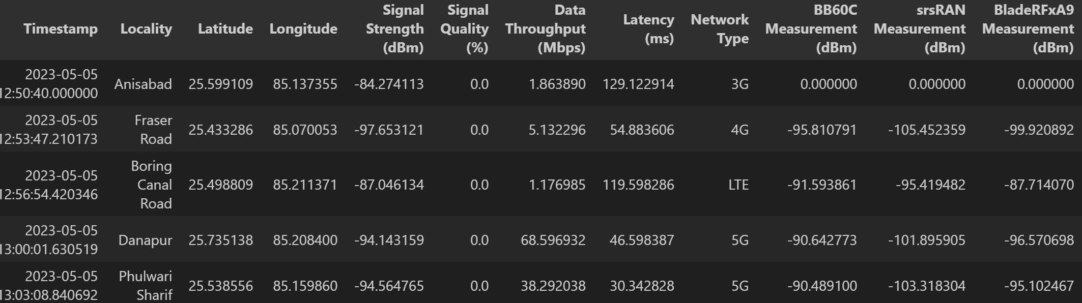
Figure 1: First 5 rows of the data set

Table 2 is a dictionary of measurements.
Measured Data | Role
Signal Strength (dBm) | Primary RF power measurement
Signal Quality (%) | signal strength relative to the maximum possible signal strength ¹
Data Throughput (Mbps) | Capacity of network
Latency (ms) | Delay of data
Network type | Standards and requirements for each network’s measurements
BB60C (dBm) | Secondary RF power measurement from spectrum analyzer
srsRAN (dBm) | “”
BladeRFxA9 (dBm) | “”
Table 2: Data dictionary
¹Data is synthetic due to unavailability.

Measurement Validation
The dataset was examined to understand the inferences and limitations of the recommendations I can make. The signal strength measurements are reported in dBm however they are not specified as RSSI, RSRP, RSCP, or SS-RSRP according to the 3GPP standards per network type.
Table 3 outlines missing pertinent data for a network optimization assessment.
Missing Data | Role
RSRP (dBm)
RSRQ (dBm)
SINR (%)
CQI
Cell IDs
Handover events

KPI Analysis
Distributions of KPIs per network are illustrated in Figure 2, Figure 3, and Figure 4.
Key Takeaway: KPIs can be compared to standards set by the network service provider and operator.

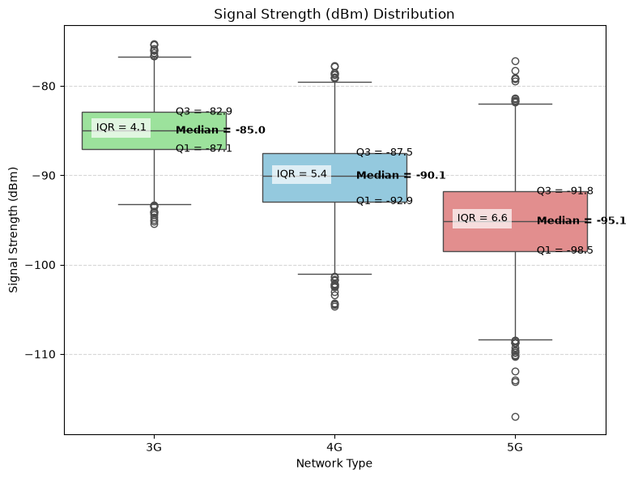
Figure 2: Signal Strength Distribution
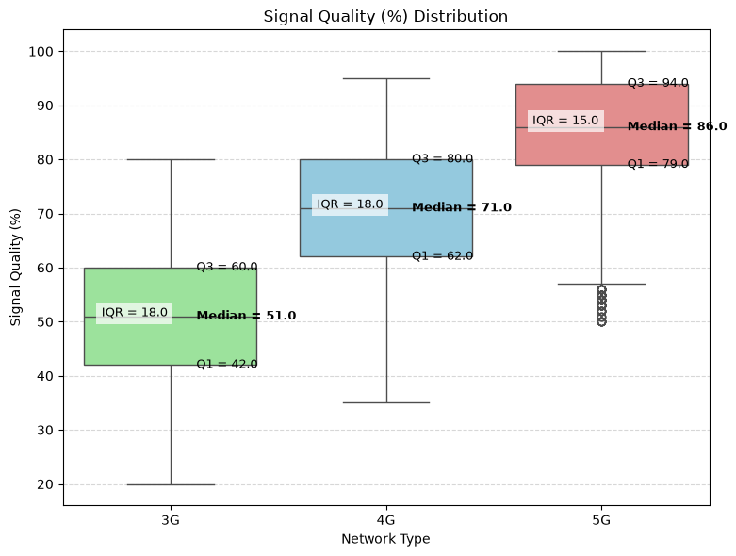
Figure 3: Signal Quality Distribution
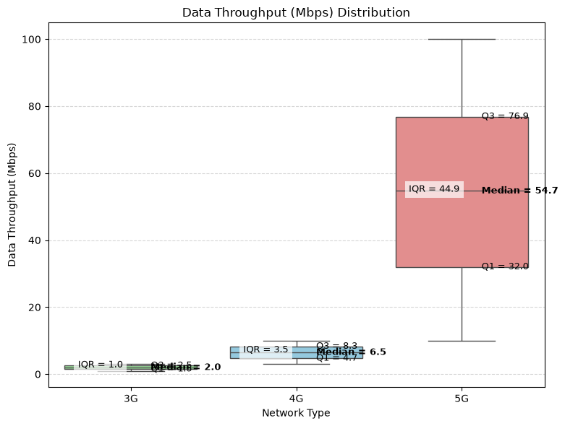
Figure 4: Data Throughput Distribution

Quality of experience (QoE) is a metric intended to position the user’s experience at the forefront by blending all of the KPIs together. This calculation was performed for every single test. The applied weighting factors were chosen to favor. The process of manipulating the raw KPI data in QoE begins with normalizing the data,
The latency values were reflected so that a higher value corresponded to a better latency.
Second, the Radio Quality Index (RQI) was calculated from the sum of the weighted normalized radio KPIs, signal quality and signal strength.
Third, the Service Performance Index (SPI) was calculated from the sum of the weighted normalized performance KPIs, data throughput and latency.
Finally, the QoE was calculated by the weighted sum of the RQI and SPI and the distribution per network type is shown in Figure 2.

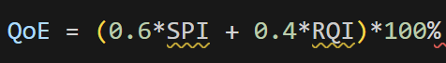
Key Takeaway: Now the users with Poor QoE ratings are identified for further analysis.
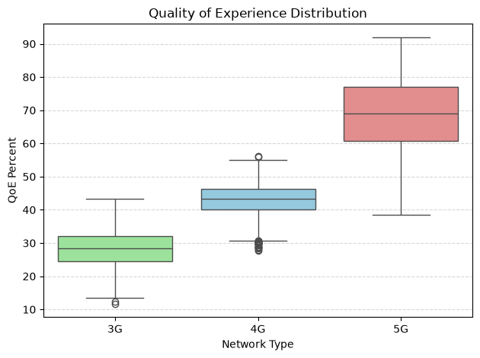
Figure 5: Distribution of QoE for all test data

Spatial Analysis
Heatmaps were produced to identify potential trends in network performance.

Optimization Recommendations

Appendix

